TEST UNIT 11

Choose the most appropriate word or phrase to fill in each blank:
- In tropical countries, _________ are used for pulling vehicles and farm equipment.
A. horses B. water buffaloes C. cows D. donkeys
- Good hygiene helps to ___________ the risk of infection.
A. reduce B. recycle C. review D. remind
- A: “Do you mind if I sit down?” – “____________.”
A. No, thanks B. Of course C. Fine, thanks D. Please do
- The ring is made ___________ gold.
A. from B. into C. of D. in
- The hotel provides _____________ for up to 500 people.
A. house B. apartment C. building D. accommodation
- His family lives in the northern ______________ region.
A. habitual B. original C. professional D. tribal
- When the boat _______________, they fell off the water.
A. overturned B. stopped C. dropped D. appeared
- You can go on excursions to visit tribal ____________ scattering here and there.
A. cities B. villages C. provinces D. towns
- You will be excited by jungle ____________ whose water continually flows with roaring sounds.
A. ponds B. streams C. lakes D. springs
- Ha Long Bay, one of the most picturesque sights in Vietnam, was _____________ as a World Cultural Heritage.
A. recognized B. collected C. signed D. realized
- __________, I get upset when things go wrong.
A. eternally B. attractively C. smartly D. naturally
- I’m going away for a few days, I’ll phone you ________ I get back.
A. when B. because C. but D. or
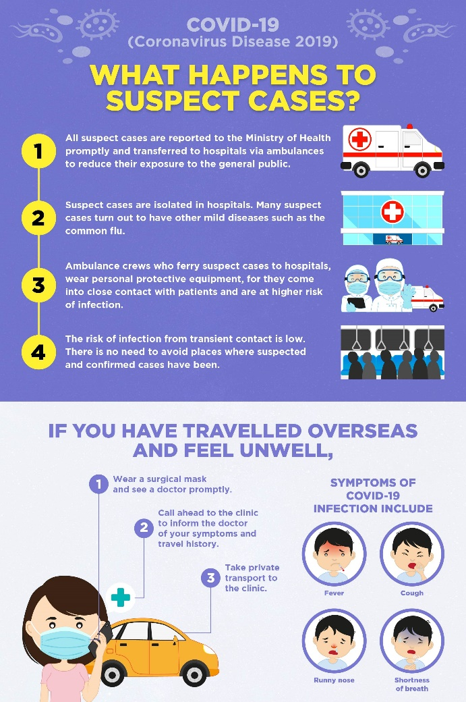
Use the correct form of the word given in each sentence:
- In this contest, participants tried to arrange flowers as ____________ as they could. (attraction)
- Many _____________ sang that song to welcome Mr. Dam. (village)
- I found Phong Nha cave _______________. (magnificence)
- Nguyen Du, a great poet of Vietnam, was _____________ as a World Cultural Celebrity. (recognition)
- The ___________ of Flight 106 from Boston has been delayed. (arrive)
- That day I was _____________ in Rome. (sightsee)

Rearrange the words and phrases given in the correct order
- / of the lake. / After hiring / the family / a canoe, / and paddled out / to the middle / climbed in //
After
- / to school. / her alarm clock / she hurriedly / go off, so / went / Lan realized / didn’t //
Lan

Read the passage. Then decide which option best fits each blank:
It was the first time Jim went to HCMC with his parents. When the plane (21) ______ at Tan Son Nhat airport, the day was fine. There was a bright sun, and the sky was (22) _______ and blue. The family took a taxi to Rex hotel, a(n) (23) _______ big hotel in city center. After checking in, they went upstairs to their room on the fifth floor. (24) ________the window of the bedroom, he could see the beautiful (25) _______ of the HCMC. Jim visited many places of interest such as Dam Sen Park, Suoi Tien, and Nha Rong Harbour. The next evening the whole family walked along the streets, (26) _______ they came into well-unknown vegetarian restaurant to enjoy delicious food. It was very wonderful.
- A. delayed B. landed C. encouraged D. departed
- A. cloudy B. humid C. wet D. cloudless
- A. extremely B. fortunately C. excitedly D. luckily
- A. By B. With C. Through D. Beside
- A. sights B. flights C. suggestions D. caves
- A. when B. but C. then D. so

Read these following passages and decide if these following statements are TRUE or FALSE
My Son is a Hindu temple complex. It is in the village of Duy Phu, 69 km southwest of Da Nang. It comprises of many Champa temples, in a valley about two kilometers wide, surrounded by two mountain ranges. It was the site of religious ceremony of kings of the Champa dynasty, and was a burial place of Champa royals and national heroes. My Son is perhaps the longest inhabited archaeological site in Indochina, but a large majority of its architecture was destroyed by US bombing during a single week of the Vietnam War.
The My Son temple complex is regarded one of the foremost Hindu temple complexes in Southeast Asia and is the foremost heritage site of this nature in Vietnam. It is often compared with other historical temple complexes in Southeast Asia, such as Borobudur of Java in Indonesia, Angkor Wat of Cambodia, Bagan of Myanmar and Ayutthaya of Thailand. As of 1999, My Son has been recognized by UNESCO as a world heritage site.
- My Son was the site of religious ceremony of kings of the Champa dynasty.
- Champa royals and national heroes used to be buried here.
- People often compare My Son to many complexes everywhere.
- My Son still maintains the whole structures up to now.
- Which of the following is NOT true?
- My Son is in a valley surrounded by two mountain ranges.
- My Son is not as famous as Angkor Wat.
- There are many Champa temples in the village of Duy Phu.
- My Son used to be a burial site.
- What does the word ‘it’ in line 3 refer to?
A. valley B. Da Nang C. village D. My Son

Write the second sentence so that it has a similar meaning to the first one:
- Jane’s close friend gave her a present last Sunday.
Jane was
- May I use your mobile phone?
Would you mind
- The window has been repaired. It was broken by the strong wind last night. (past participle)
The window
- Living in this city is not safe because the air is polluted.
It

